Experiment 01:-

Problem Statement:-
Write a Python program that calculates the area of a circle when the radius is provided by the user. Use pi = 3.14 and display the area.

Algorithm:-
- Start
- Read the radius r from the user
- Calculate the area using the formula:
Area = 3.14 × r × r
- Display the area
- Stop.

Flowchart:-
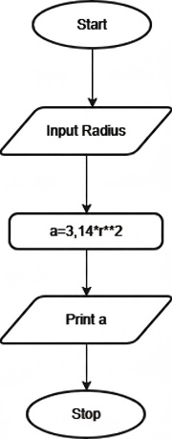

Execution:- 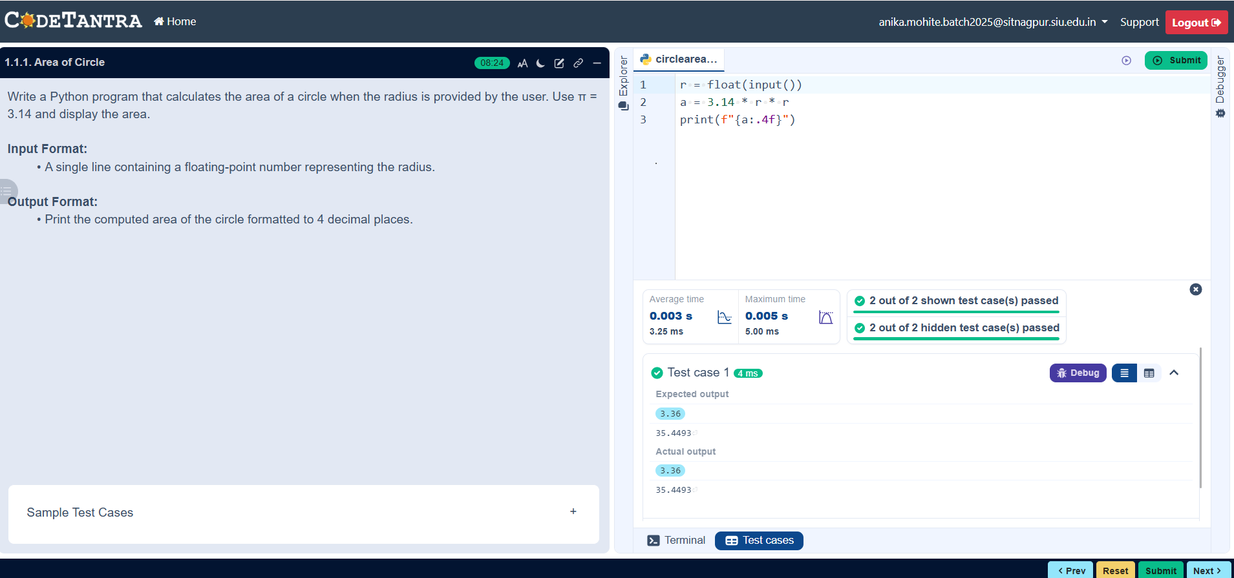

1

Problem Statement:-
Write a Python program to calculate the area of a rectangle given its length and width.

Algorithm:-
- Start.
- Read the length l and Width b from the user.
- Calculate the area using the formula:
Area = l*b.
- Display the area.
- Stop.

Flowchart:-
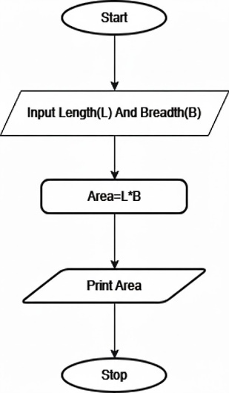
Execution:- 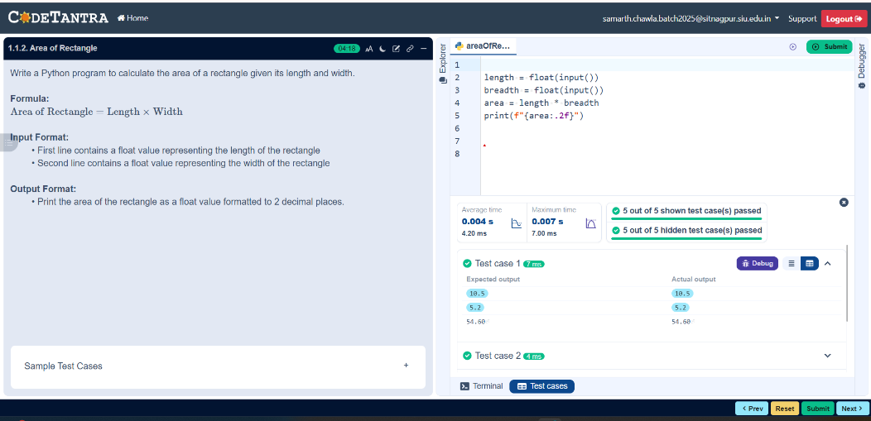

2

Problem Statement:-
Write a Python program that prompts the user to enter the Side Length of a square and computes the area of the square.

Algorithm:-
- Start.
2. Read the side length s of the square.
3. Calculate the area using the formula: Area=𝑠×𝑠.
4. Display the area
5. Stop.

Flowchart:-
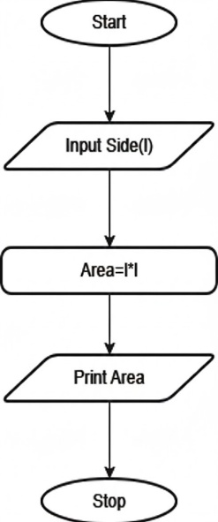
Execution:- 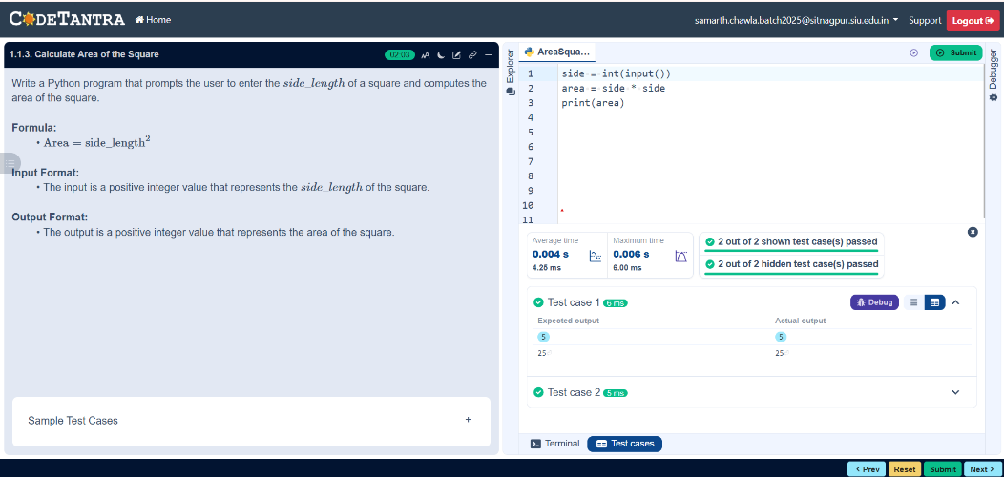

3

Problem Statement:-
Write a Python program that prompts the user to enter the triangle's base and height and computes the triangle's area.

Algorithm:-
- Start.
- Read the base b and height h of the triangle.
- Calculate the area using the formula: Area=0.5×𝑏×ℎ.
- Display the area.
- Stop.

Flowchart:-
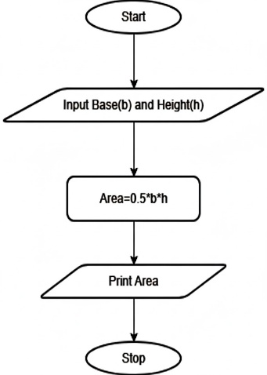
Execution:-
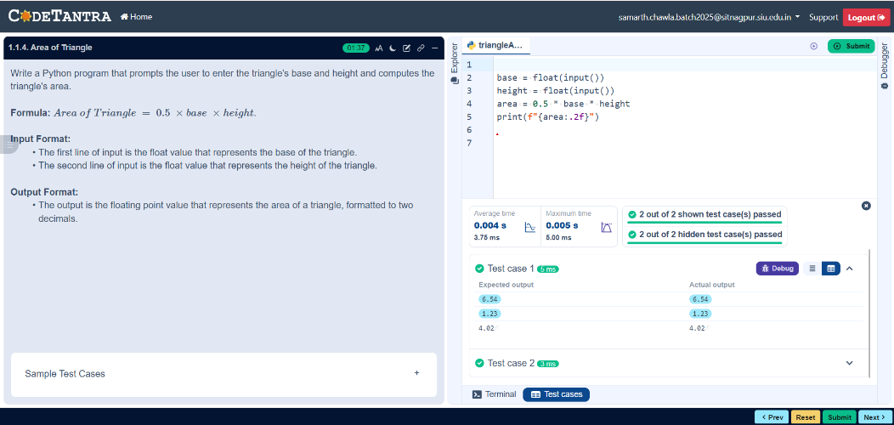

4

Problem Statement:-
Write a Python program to determine whether a student passed the exam or not based on their marks.

Algorithm:-
- Start.

- Read the marks obtained by the student.

- If marks > 40 → Display “Pass”.

- Else → Display “Fail”.

- Stop.

Flowchart:-
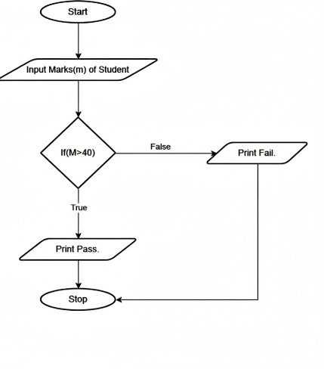
Execution:-
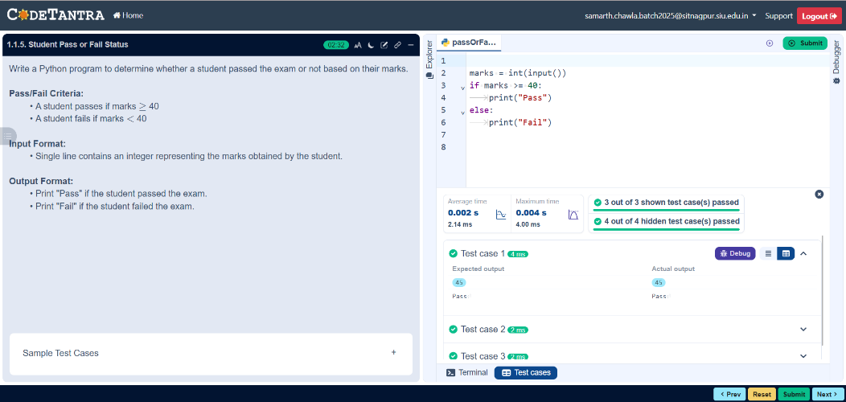

5

Experiment 02:-

Problem Statement:-
Write a program to find the roots of a quadratic equation, given its coefficients a, b, and c. Use the quadratic formula: (-b+-root(b**2-4ac))/2a.

Algorithm:-
- Start.

- Read the coefficients a, b, and c.
- Calculate the discriminant using:- 𝐷=𝑏^2−4ac.

- If D > 0 Compute:- 𝑥1=(−𝑏+root𝐷)/2a and 𝑥2=(−𝑏−root𝐷)/2𝑎 Display two real and distinct roots.

- Else if D = 0 Compute:- 𝑥=−𝑏/2𝑎 Display equal real roots.

- Else (D < 0) Compute:- Real part = −𝑏/2𝑎 Imaginary part = root(-𝐷)/2a Display complex roots.

- Stop.

Flowchart:-
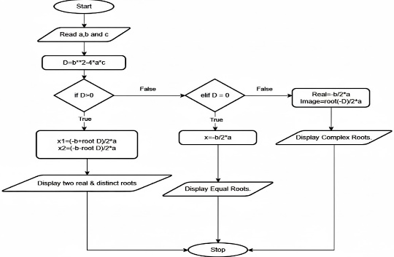
Execution:-
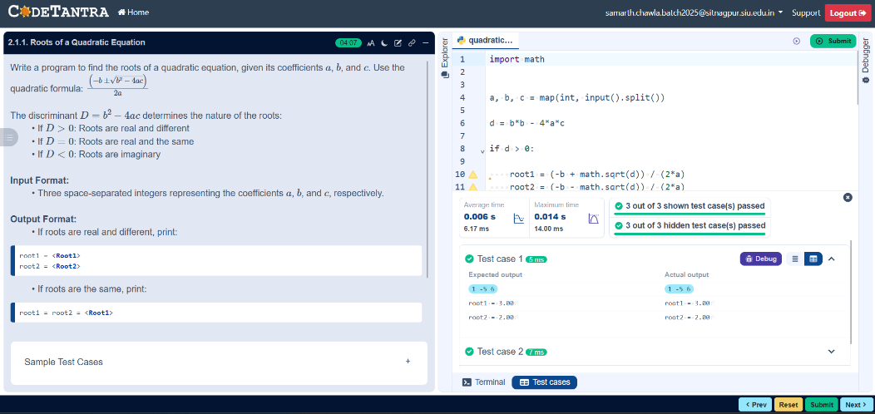

6

Experiment 03:-

Problem Statement:-
Write a Python program to convert temperature from Celsius to Fahrenheit.

Algorithm:-
- Start.
- Input temperature in Celsius C.
- Calculate Fahrenheit using the formula F = (C × 9/5) + 32.
- Display the temperature in Fahrenheit.
- Stop.

Flowchart:-
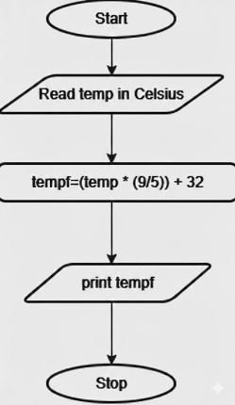
Execution:- 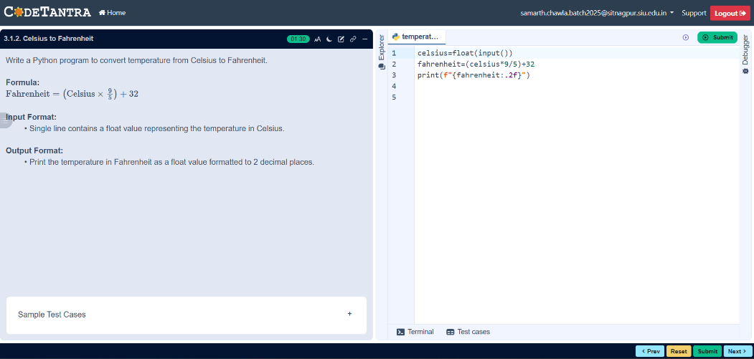

7

Problem Statement:-
Write a Python program that prompts the user to enter three integers. Print the largest of the three integers.

Algorithm:-
- Start.
- Input three integers a, b, and c.
- If a ≥ b and a ≥ c → Print a as the largest number.
- Else if b ≥ a and b ≥ c → Print b as the largest number.
- Else → Print c as the largest number.
- Stop

Flowchart:-
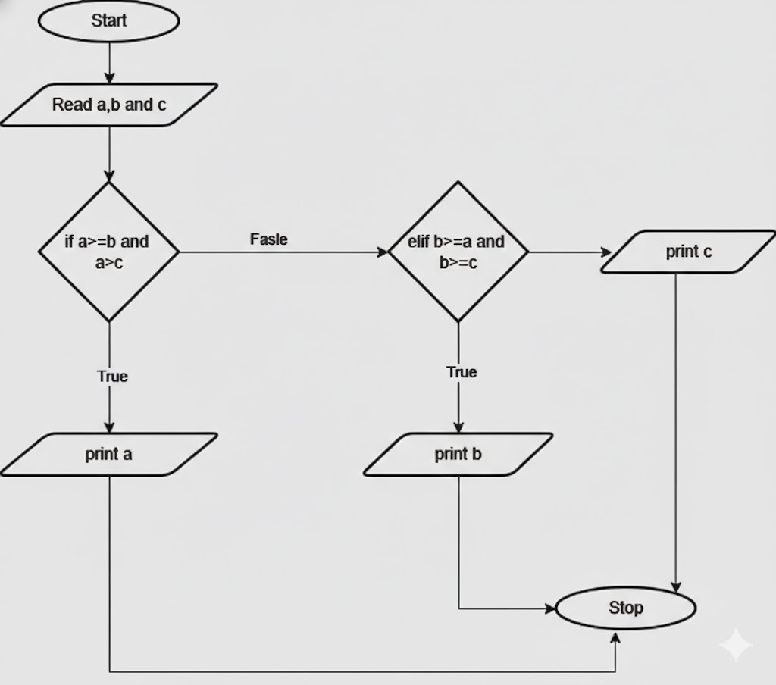
Execution:-
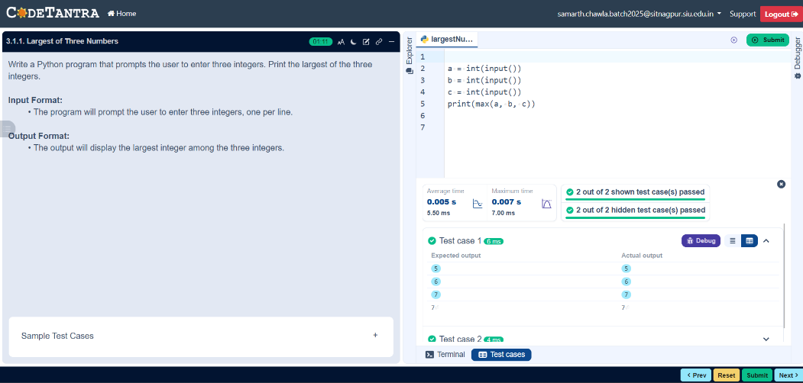

8

Experiment 04:-

Problem Statement:-
Write a Python program to perform union, intersection and difference operations on Set A and Set B.

Algorithm:-
- Start.
- Declare two sets A and B
- Read elements of Set A from the user
- Read elements of Set B from the user
- Perform Union operation Union = A ∪ B.
- Perform Intersection operation Intersection = A ∩ B.
- Perform Difference operations
- Difference1 = A − B.
- Display Set A and Set B
- Display Union, Intersection, and Difference results
- Stop.

Flowchart:-
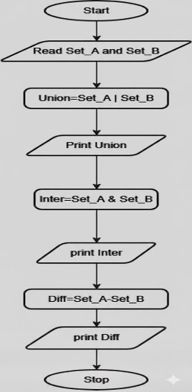
Execution:-
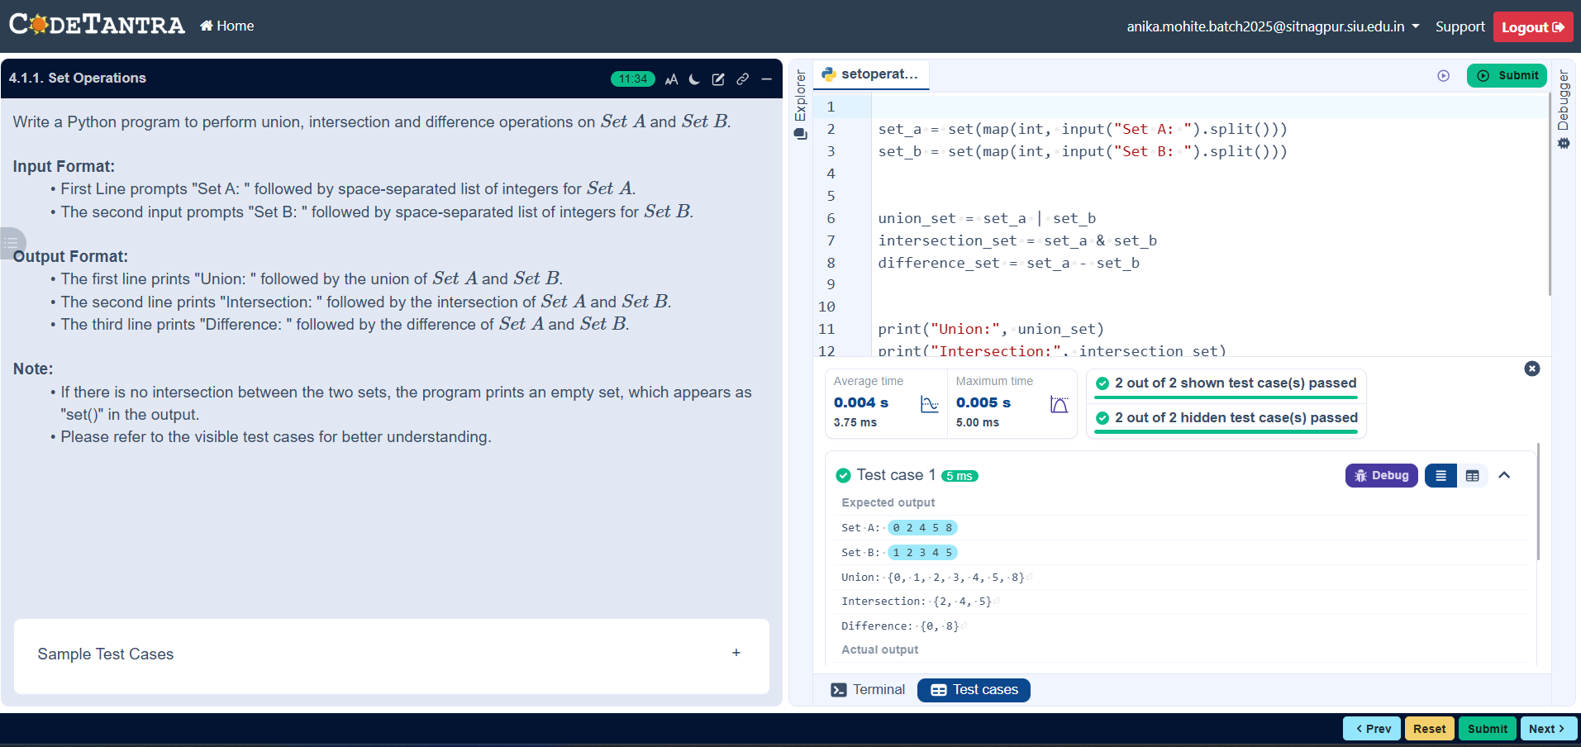

9

